Group 8

Abhishek Rai

Jack Dayton

Himanshu Jagtap

**SQL-Mongo Project – Spatial Data of US Wildfires**

BUAN 6320

|  |  |  |  |  |
| --- | --- | --- | --- | --- |
| **Activity** | **Member 1** | **Member 2** | **Member 3** | **Member 4** |
| Prepared Data Model and Created Physical DB | x |  |  |  |
| Loaded Data into Database |  | x |  |  |
| Wrote SQL Queries |  | x |  |  |
| Prepared Mongo Database |  |  | x |  |
| Loaded data into Mongo DB |  |  | x |  |
| Wrote Mongo Queries |  |  |  | x |
| Prepared Report |  |  | x | x |
| Reviewed Report | x | x |  |  |

Contents

Relational Data Model 4

Assumptions/Notes About Data Entities and Relationships 4

Entity-Relationship Diagram 4

Physical MySQL Database 5

Assumptions/Notes About Data Set 5

Screen shot of Physical Database objects 5

Data in the Database 5

SQL Queries 6

SQL Query 1 6

Question 6

Notes/Comments About SQL Query and Results (Include # of Rows in Result) 6

Translation 6

Screen Shot of SQL Query and Results 6

SQL Query 2 7

Question 7

Notes/Comments About SQL Query and Results (Include # of Rows in Result) 7

Translation 7

Screen Shot of SQL Query and Results 7

SQL Query 3 8

Question 8

Notes/Comments About SQL Query and Results (Include # of Rows in Result) 8

Translation 8

Screen Shot of SQL Query and Results 8

SQL Query 4 9

Question 9

Notes/Comments About SQL Query and Results (Include # of Rows in Result) 9

Translation 9

Screen Shot of SQL Query and Results 9

SQL Query 5 10

Question 10

Notes/Comments About SQL Query and Results (Include # of Rows in Result) 10

Translation 10

Screen Shot of SQL Query and Results 10

SQL Query 6 11

Question 11

Notes/Comments About SQL Query and Results (Include # of Rows in Result) 11

Translation 11

Screen Shot of SQL Query and Results 11

Data Review for MongoDB 12

Assumptions/Notes About Data Collections, Attributes and Relationships between Collections 12

Physical Mongo Database 13

Assumptions/Notes About Data Set 13

Screen shot of Physical Database objects (Database, Collections and Attributes) 13

Data in the Database 13

MongoDB Queries/Code 14

Mongo Query 1 14

Question 14

Notes/Comments About MongoDB Query/Code and Results (Include # of Documents in Result) 14

Translation 14

Screen Shot of MongoDB Query/Code and Results 14

Mongo Query 2 15

Question 15

Notes/Comments About MongoDB Query/Code and Results (Include # of Documents in Result) 15

Translation 15

Screen Shot of MongoDB Query/Code and Results 15

Mongo Query 3 16

Question 16

Notes/Comments About MongoDB Query/Code and Results (Include # of Documents in Result) 16

Translation 16

Screen Shot of MongoDB Query/Code and Results 16

# Relational Data Model

## Assumptions/Notes About Data Entities and Relationships

**Include reasons why the data model is in 3NF.**

We have made the employeesdetails table the main table in our model because all of the other tables should relate back to an individual employee and thus the EmployeNumber, which is the primary key for this table. Each other table in the model relates to the employeesdetails table, so the primary key for each other table is also in the employeesdetails table as the foreign keys. Every relationship between tables is also 1:1, as each entry is one employee who has one job and who takes one survey.

* **The model is 1NF** because all rows have the same number of columns and all values are singular.
* **The model is 2NF** because each column is fully functionally dependent on the primary key for that table. We created individual ID primary keys for each table that all relate to the employee table.
* **The model is 3NF** because there is no transitive dependency for non-prime attributes as well as it is in the second normal form. Each column of the table depends on its primary key only.

We have created the primary for all the tables except for the employeedetails table.

Assumptions:

1. We have assumed that each Employee has Age over 18 and this is not going to change in the future.
2. We have assumed that each employee has Standard working hours equal to 80 hrs which is not going to change in the future.
3. We have assumed that employee Count remains 1 for each employee.
4. We have also assumed that Each employee has its daily and monthly Rate other than Monthly Income and these rates are used to bill clients of the company providing service to them.
5. We also assume that Distance from home is the distinct relative quantity and higher the value means farther is the distance from home.
6. We are also assuming that Education value denotes the level of education means higher the value of an education means highly educated that employee is.
7. We assume that one employee will be from one education field only.
8. We assume that stock option level means a benefit plan that employee chooses based on preference and it does not mean that higher the stock level leads to higher stock ownership by an employee. E.g. employee having a higher salary but stock option level of 1 means he must be taking benefits equivalent to 10% of his salary. That means he has stocks of 10% of his salary.
9. We assume Overtime attributes give the idea that employee has done overtime for that month meaning worked more than standard hours.
10. We assume that hourly rate is used to calculate the overtime income with whatever ours of overtime is done by an employee.
11. We are assuming for each department they have multiple Job roles and for each role, they have multiple Job levels. Job role defines the work of the person whereas Job level defines the hierarchy structure in the role.
12. We assumed that one employee did not take multiple surveys.
13. We assumed that one person was not working multiple different jobs and thus worked for two different companies or took surveys for each job.
14. We assumed that there were not multiple entries for the same employees.

## Entity-Relationship Diagram

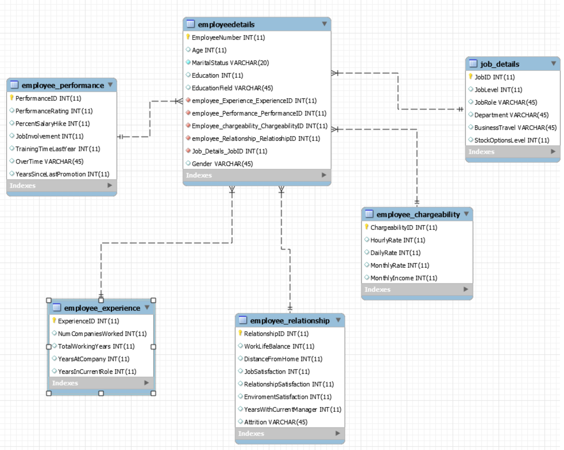

# Physical MySQL Database

## Assumptions/Notes About Data Set

Include any assumptions made about data such as empty fields, sparse data, bad data, etc.

There are no empty fields or sparse data in the data set.

We are assuming for the value ‘0’ that the employee does not have that data like is

## Screen shot of Physical Database objects

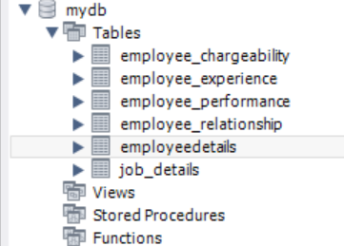

* Employee_Experience Table: 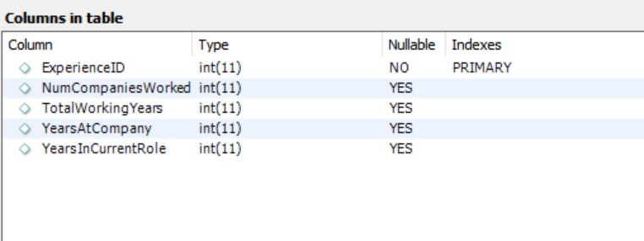

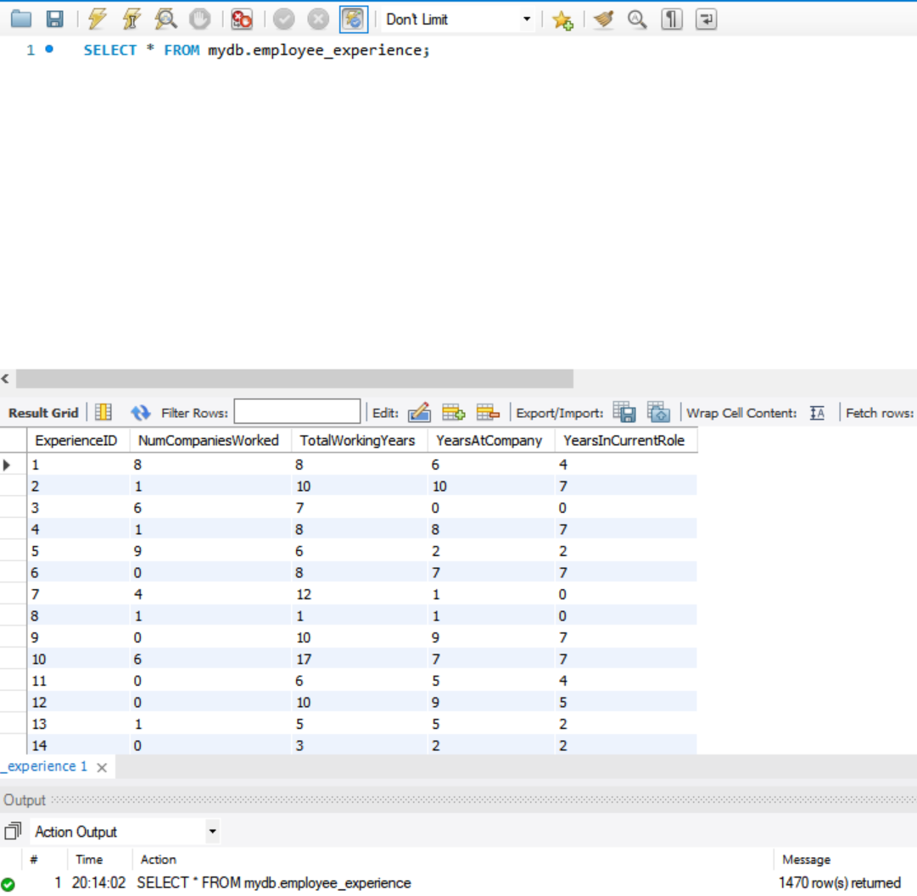

* Employee_Performace Table: 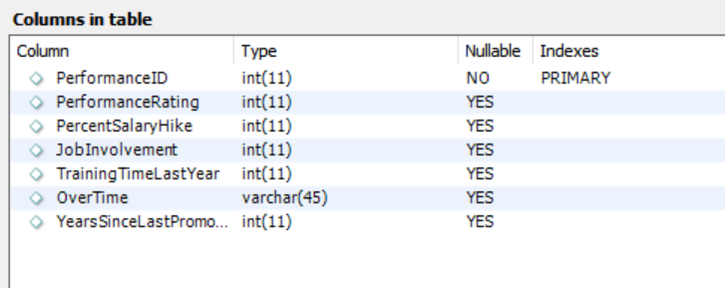
* Employee_Chargeability:

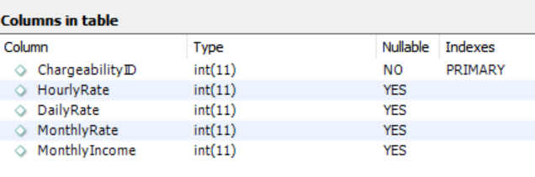

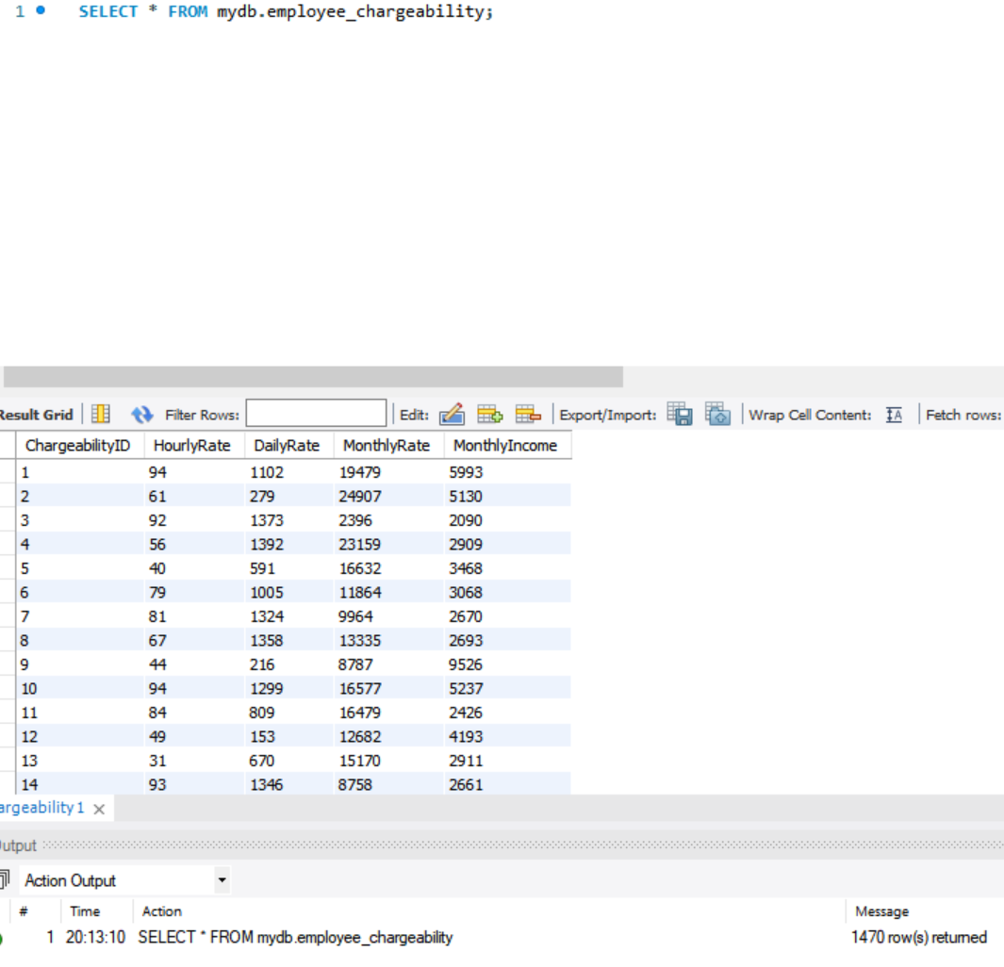

* Employee_Relationship: 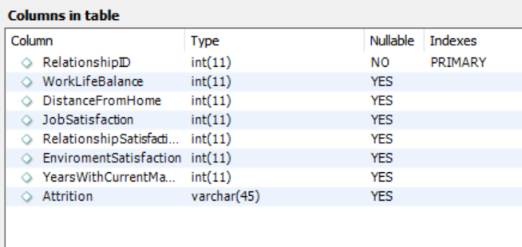
* Employee details tables: 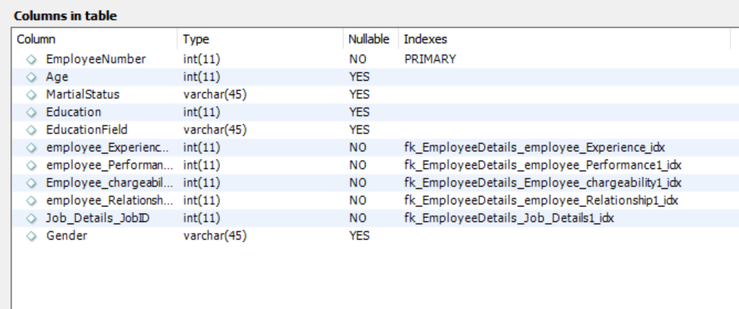

* JoB_Details:

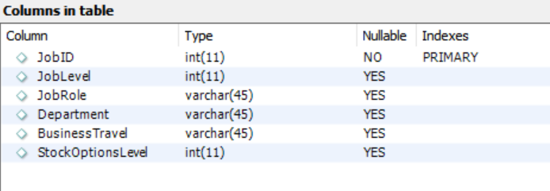

## Data in the Database

|  |  |  |  |
| --- | --- | --- | --- |
| **Table Name** | **Primary Key** | **Foreign Key** | **# of Rows in Table** |
| Job_details | JobID | No Foreign Key | 1470 |
| EmployeeDetails | EmployeeNumber | 1. employee_Experience_ExperienceID 2. employee_Performance_PerformanceID 3. Employee_chargeability_ChargeabilityID 4. employee_Relationship_RelatioshipID 5. Job_Details_JobID | 1470 |
| employee_performance | PerformanceID | No Foreign Key | 1470 |
| employee_chargeability | ChargeabilityID | No Foreign Key | 1470 |
| employee_experience | ExperienceID | No Foreign Key | 1470 |
| employee_relationship | RelationshipID | No Foreign Key | 1470 |

# SQL Queries

## SQL Query 1

### Question

### Notes/Comments About SQL Query and Results (Include # of Rows in Result)

### Translation

### Screen Shot of SQL Query and Results

## SQL Query 2

### Question

### Notes/Comments About SQL Query and Results (Include # of Rows in Result)

### Translation

### Screen Shot of SQL Query and Results

## SQL Query 3

### Question

### Notes/Comments About SQL Query and Results (Include # of Rows in Result)

### Translation

### Screen Shot of SQL Query and Results

## SQL Query 4

### Question

### Notes/Comments About SQL Query and Results (Include # of Rows in Result)

### Translation

### Screen Shot of SQL Query and Results

## SQL Query 5

### Question

### Notes/Comments About SQL Query and Results (Include # of Rows in Result)

### Translation

### Screen Shot of SQL Query and Results

## SQL Query 6

### Question

### Notes/Comments About SQL Query and Results (Include # of Rows in Result)

### Translation

### Screen Shot of SQL Query and Results

# Data Review for MongoDB

## Assumptions/Notes About Data Collections, Attributes and Relationships between Collections

# Physical Mongo Database

## Assumptions/Notes About Data Set

## Screen shot of Physical Database objects (Database, Collections and Attributes)

## Data in the Database

|  |  |  |
| --- | --- | --- |
| **Collection Name** | **Relationships With Other Collections (if any)** | **# of Documents in Collection** |
|  |  |  |

# MongoDB Queries/Code

Pick 3 SQL queries and write them in MongoDB

## Mongo Query 1

### Question

### Notes/Comments About MongoDB Query/Code and Results (Include # of Documents in Result)

### Translation

### Screen Shot of MongoDB Query/Code and Results

## Mongo Query 2

### Question

### Notes/Comments About MongoDB Query/Code and Results (Include # of Documents in Result)

### Translation

### Screen Shot of MongoDB Query/Code and Results

## Mongo Query 3

### Question

### Notes/Comments About MongoDB Query/Code and Results (Include # of Documents in Result)

### Translation

### Screen Shot of MongoDB Query/Code and Results